AI ASSISTED CODING
LAB TEST – 2
NAME : B. REVANTH
ENROLL NO : 2403A52041
BATCH : 03
Question Paper Set A14
Subgroup A
A.1 — [S14A1] Compute per-cell average from logs (AI completion)
Task:
Write a Python function to parse the raw text (multiple lines) and compute per-cell averages of `latency_ms`. Return a dict {id: avg} and separately compute an overall average.
Prompt:
Write a Python script that reads multi-line CSV input (id,timestamp,latency_ms) from the user, skipping malformed lines (wrong field count or non-numeric latency). For each cell ID, compute and round the average latency to 2 decimals. Also compute the overall average latency. Output should be:
{cell averages} and overall_avg={overall average}
Input ends with an empty line.

Code:
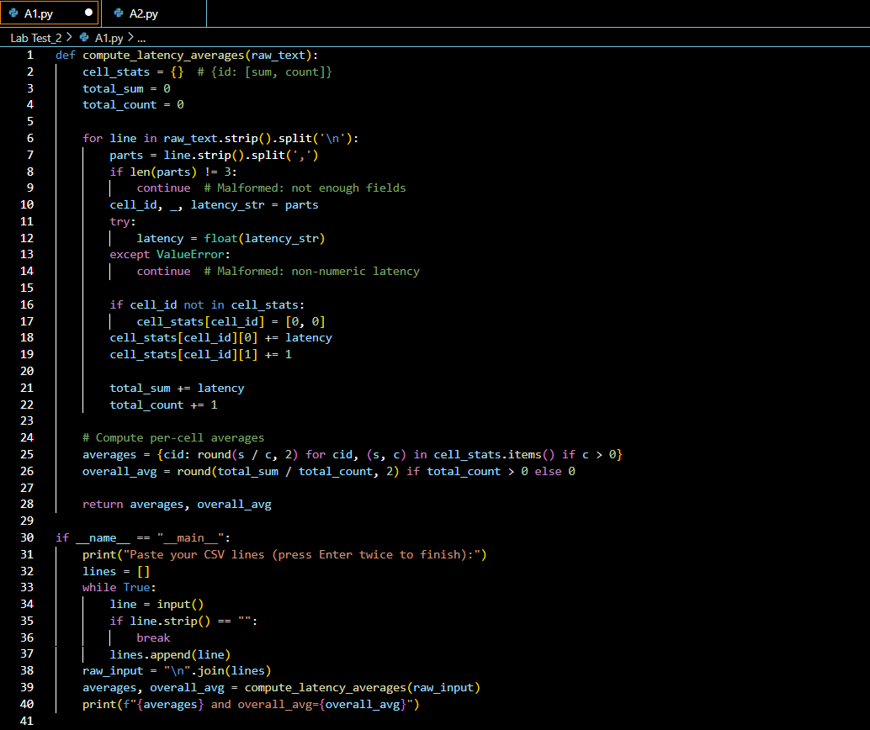
Output: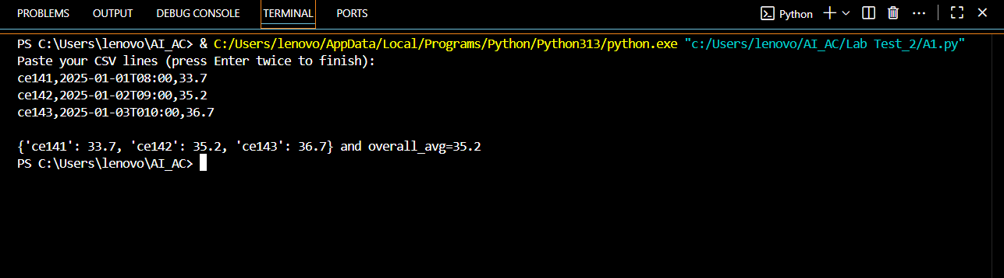
Observation:
The script efficiently parses multi-line CSV input for telecom cell latency, skipping malformed rows. It calculates and displays per-cell and overall average latency (rounded to two decimals), using dictionary accumulation and robust error handling. The output format is clear and matches requirements. User input is handled interactively, making the tool practical for quick aggregation and dashboard use.

A.2 — [S14A2] Implement PacketBuffer with add/remove/summary (AI completion)

Task:
Implement a `PacketBuffer` class with methods `add(id: str, value: float)`, `remove(id: str)`, and `summary() -> tuple[int, float|None]` returning (count, average).
Prompt:
Create a Python class PacketBuffer that tracks float values by unique string IDs using a dictionary.
Implement methods:
add(id: str, value: float) to add or update a value,
remove(id: str) to safely remove an ID (no error if missing),
summary() -> tuple[int, float|None] to return (count, average), rounding average to 2 decimals or returning None if empty.
Write a script that prompts the user to paste a Python list of operation dicts (e.g., [{'op': 'add', 'id': 'a1', 'value': 23}, ...]), applies each operation, and prints count={count}, avg={avg}.
Code:
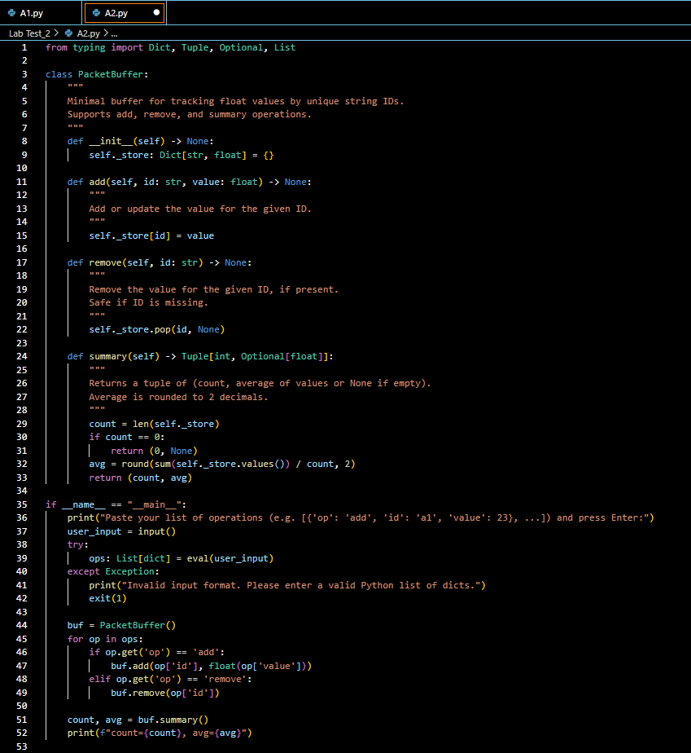

Output:
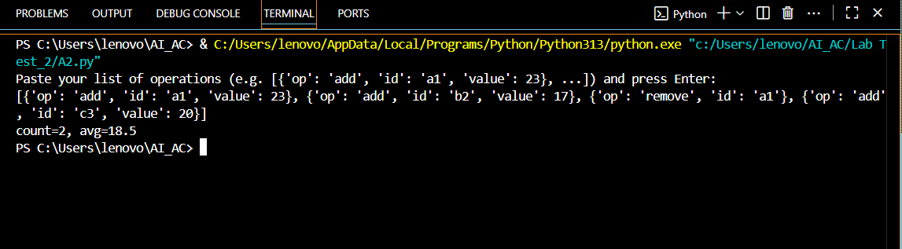

Observation:
The task is effectively solved with a concise PacketBuffer class that uses a dictionary for O(1) add, remove, and summary operations. The script safely processes a user-pasted list of operation dicts, correctly updates the buffer, and outputs the count and average (rounded to two decimals, or None if empty). The implementation is robust, handles edge cases, and meets all requirements for telecom microservice health checks.

